**ASP Web API Post Method – From Uri**

**Objectives**

* Describe about Web API Post method
* Explain FromUri attribute
* Explain how to use FromUri attribute.

In this hands-on lab, you will learn how to:

* Implement a Web Api Post method with FromUri attribute.

**Prerequisites:**

The following is required to complete this hands-on lab:

* Visual Studio 2017 Community Edition

**Notes:**

Estimated time to complete this lab:**60 minutes**.

**Create a Web Api Project**

**Step 1:**

Create an Api controller called BrandsController. Add a Post method with a parameter called brand of type Brand and method will add the new brand detail to the existing brand list. Post method return type should be ‘HttpResponseMessage’. After adding a new brand return the newly added brand with a ‘HttpStatusCode’ for new object created**.**

**Step 2:**

**Note: Use [FromUri] attribute for brand input.**

Create a Model class in models folder as Brand.

Create a static list of brands as given in the screenshot. Brand List:

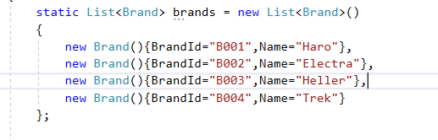

**Output in Postman tool:**

**The Url will be**

<http://localhost:63584/api/Brands?BrandId=B005&Name=Surly> with a POST request in Postman

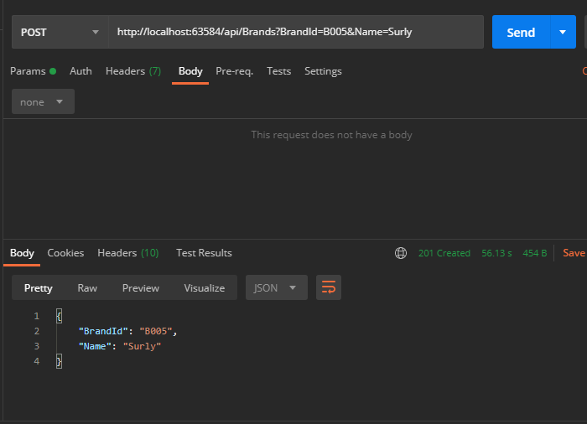

HttpStatusCode